**Low Cost Fully Automated Bag Valve Mask**

**Abstract**

In today’s scenario the COVID 19 cases are increasing rapidly and most of them are suffering from breathing problems. So hospitals are providing ventilators to support the patients and due to the huge number of cases there is a shortage of ventilators. There are some which can be used as a ventilator live BVM ventilator. But this involves a controller person who will control the Bag. And it is a high risk to have someone near to an infected person. So this product fills the need of the supporting person with the help of an automated machine for pumping Bag Valve Mask. This is a low-cost ventilator product that can be used by hospitals for the patients who are facing breathing problems. This is a mechatronics engineered product which consists of Bag Valve Mask which is used for BVM Ventilation. This ventilation is an alternative and most effective ventilation process, when the person can’t breathe on their own, BVM pushes air to the lungs. But pushing air to the lungs involves monitoring many external parameters like heart rate and lung Inflation. This product will ensure monitoring both cases at the same time. It will monitor heart rate and also mechanically pump air without the help of any person. The real objective of this product is to give doctors enough time to arrange any alternative, so that they can help patients to survive that situation.

**Introduction**

Respiratory disorder and damage induced by the respiratory collapse constitute a huge problem in both advanced and less advanced nations.Asthma,Chronic Obstructive Pulmonary Disease (COPD),Chronic Bronchitis,Emphysema,Lung Cancer,Cystic Fibrosis/Bronchiectasis,

,Pneumonia,Pleural Effusion has been a worldwide problem.All of these diseases are caused due to smoking,air pollution,smoke from burning of fuel etc which are on the peak in both the advanced and less advanced nations.Patients with crucial lung diseases may develop respiratory problem which can only be maintained by ventilation.Mechanical ventilators assists patient to inhale as well as exhale as it eliminates the extra energy of labored breathing in the critical condition.The ventilators used in the hospitals costs high which prohibits for the use in poor countries.As in the case of outbreak in Covid 19 the patients suffering from the fever needs constant ventilation.Furthermore the ventilators can go vulnerable if not maintained properly. Keeping that in mind low cost portable ventilator has been designed.The ventilator enables the monitor to set up an alarm to the caregiver, indicating an increase in air pressure when patients' condition goes fragile.The parameters can be monitored and also controlled using a PC or Mobile device and the Doctors will be instantly notified if any anomaly happens.

**Product Requirements:**

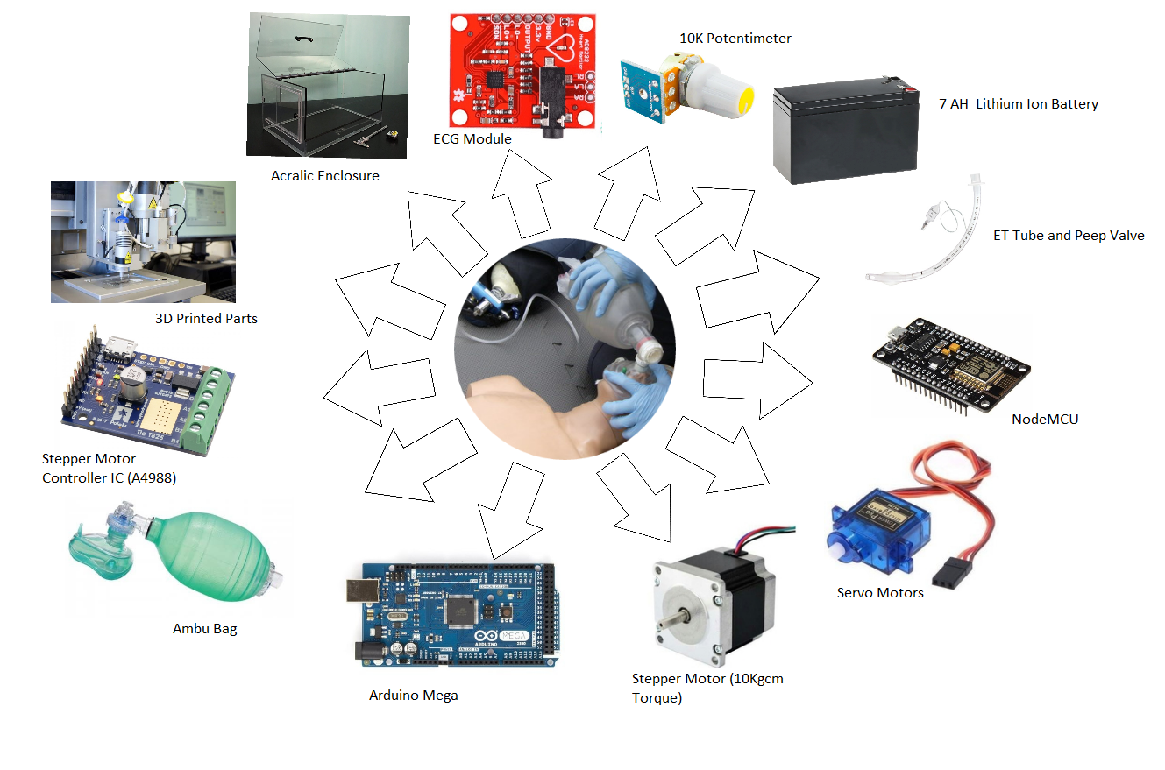

**Methodology**

BVM bag also known as Ambu bag which is used as a manual resuscitator[7]. This is a self inflating bag used to provide positive pressure ventilation to the patients who are having trouble in breathing[3]. This bag is used in the area where there is no access to ventilator machines. And due to the pandemic the use of these BVM can help the large number of infected patients to survive. But this BVM needs a person who can press the bag to push the air to the lungs.

To make it autonomous we have created a mechatronic control system which can autonomously pump the air using mechanical hands. These hands will press the bag to pump air to the patient's lungs. This hands frequency can be varied and also the time interval between every press can also be varied using a regulator or can also be controlled with mobile or computer. This will allow the doctors to vary the pressure and the rate of air flow. This process can prevent damage of lungs or air sacs which can lead to Pneumothorax.

According to the safety and regulations guidelines the bag is squeezed once every 6 seconds for adults (10 ventilations per minute) and every 3 seconds for infants (20 ventilations per minute)[4]. And the average volume of BVM is 1600 mL. Squeezing the bag at full strength is generally not necessary[2]. It is recommended that it should be squeezed 1/3rd of its volume[6].

To monitor the health of the heart we have used an ECG module (AD8232) to get real-time heart health monitoring. The use of ECG is for a very important and specific purpose. As we know if the CO2 level rises inside the bloodstream it can create an alarming situation. As CO2 increases the blood pH decreases, Heart rate and blood pressure increases and this can lead to hypercapnia or hypercarbia like problems. So ECG will help to monitor the real-time heart rates and can also help to vary the change in the frequency of ambu bag squeezing and also to change the volume of air transfer.

We can also pump oxygen by connecting oxygen reservoir connections to the ambu bag which will give concentrated oxygen. This reservoir connected to the bag when used as a source of oxygen in nonintubated spontaneously breathing patients.The flow of oxygen at a rate > 15 L/min and also can be varied.

This product is powered by a Lithium ion 7AH battery which will allow the product to run for more than 40+ days with a continuous use.

**Working Principle**

* The product is placed near to the patient's bed.
* The ECG sensor is used to monitor the heart health and the heart rate. This will also let the doctor know about the CO2 content in the blood
* The Mechanical hands are used to squeeze the bag.
* The hands pressure and the time interval of squeezing can be controlled using a computer (IoT based platform) or in the device itself.
* Pressure is precisely controlled using a calibrated flow sensor that measures volumetric flow.
* Every sensor data is sent to the cloud and also to the local server so as to avoid medical data loss.
* The sensor values can be viewed in the IoT platform and the hands can be controlled directly from the operators window.
* At the point of emergency the system will alert the operator and the doctor.

**Procedures (Flow Charts)**

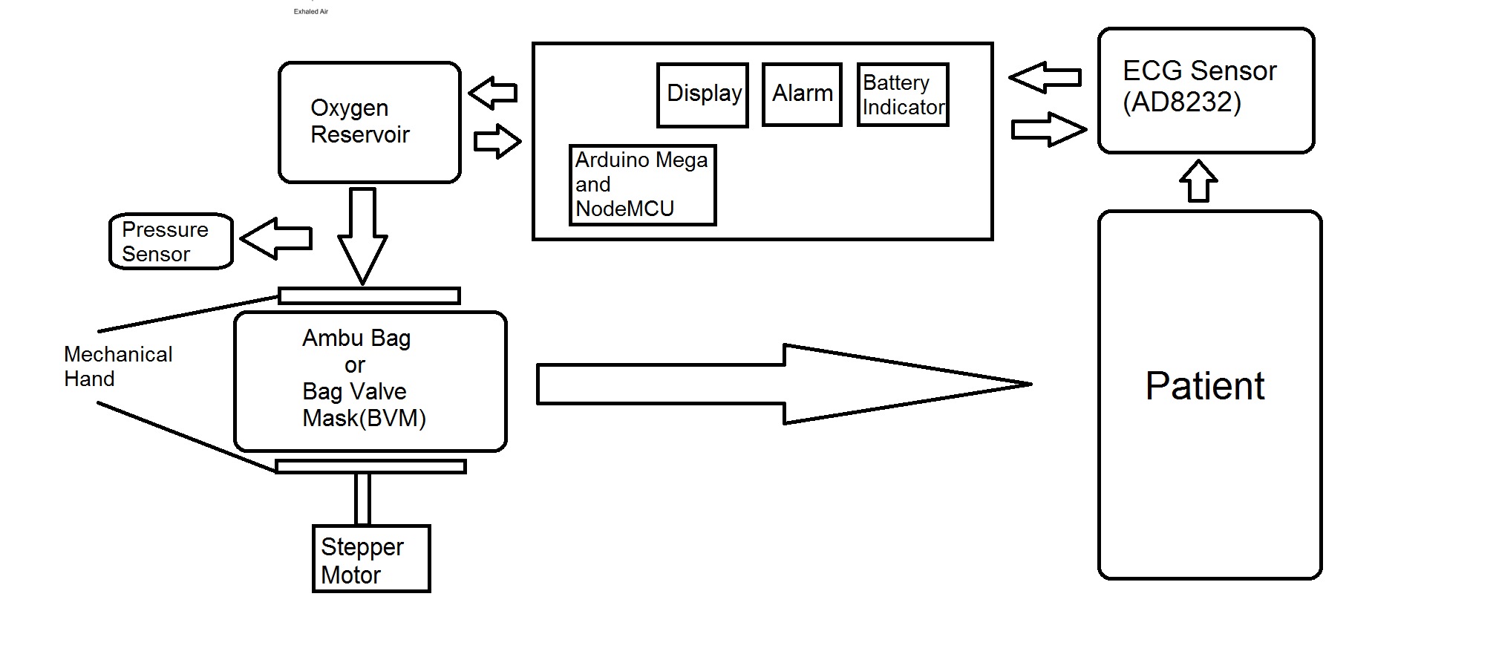

**Fig: Patient Side Product**

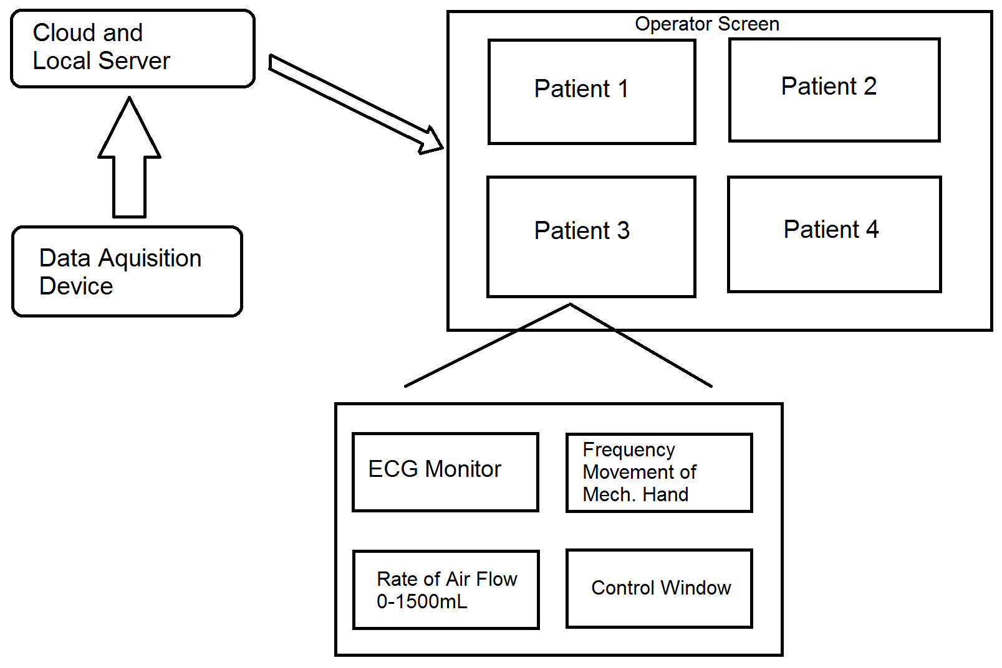

**Fig: OPERATOR SIDE PRODUCT**

The basic premise of the working of this device depends on the specifications of the Ambu Bag. In general 300ml, 500ml and 1700ml Ambu Bags are used for infants, children and adults respectively. But since we can control the specific amount of air volume with mechanical precision, we only need the 1700ml (with upto 100ml variation) Ambu bag for all purposes.

**DISPLACEMENT CALCULATION OF MECHANICAL HANDS:**

By repeated testing of a standard specification Ambu bag we shall find out how much displacement of the mechanical hand causes how much displacement of volume of air. This shall be done using a small flowmeter incorporated in the tubing. The flowmeter has a fan attached to a motor. It's rotation shall generate an analog output. Thus during the testing phase we shall get specific analog values for the amount of volume displacement.

Additionally we can also use this flow meter as a safety failsafe feature as we can also use this to check real time volumetric flow rates. This would require certain calibrations during test phase. Any sudden change in conditions like less volumetric flow due to high temp, atmospheric pressure related variations, leaks etc can be detected in real-time as the volumetric flow within the tube is prioritized and monitored. This shall also mean that the system would be very precise and consistent which is not possible by human control.

Thus clearly an automated system can be created on this basis. Yet for the time being, we have considered a supervised approach.

**MONITORING THE PATIENT:**

The patient shall be monitored continuously using an ECG sensor. All the data from the sensor as well as the flowmeter shall be processed by an Arduino mega and collected via nodeMCU. The output generated will be a continuous graph with respect to time and shall be displayed on a screen in real-time. So the ECG of the patient will be continuously visible as well as the instantaneous flow-rate.

Alternatively a mass supervision system can be made where the data is uploaded continuously via a data acquisition device to a local or cloud server, where one medically trained supervisor can oversee many patients at the same time from safety of home.

**CONTROL OVER DEVICE:**

As per requirement, on the basis of age of patient and other factors the frequency of compression of the BVM and volumetric displacement of air shall vary. So we need to control these 2 parameters. Thus clearly by controlling the range of movement of the mechanical hands and the frequency of the stepper motor this can be easily achieved.

One of the mechanical hands shall be fixed and the other shall be connected to the motor. Based on the amount of volumetric displacement required, (calculated from a calibrated flow meter reading) the range of movement shall be controlled. Gears used with the motor will be

such that one complete rotation causes full compression. Thus by controlling the percentage of rotation using flow meter analog readings we can control the hand movement.

Frequency can be easily controlled as it doesn't vary very much from patient to patient and does not require special use cases as such. It can be controlled using timing the delay of the motor after each compression and expansion cycle.

Thus if a supervisor has real-time or online control over these 2 parameters he/she can easily control many devices at once which would be impossible manually by hand.

**Product Design (3D Model)**

This is the prototype design of the ventilator machine.The main part of it is the Bag Valve mask (BVM). The BVM is squeezed and released after a certain interval by a lever which is connected to a screw. The screw is controlled by a stepper motor. The lever will press the bag whenever the motor rotates the screw in a clockwise direction and the lever releases the bag when the motor rotates the screw anticlockwise. The motor is controlled by the control unit which is present on the product itself and also controlled by the IoT.

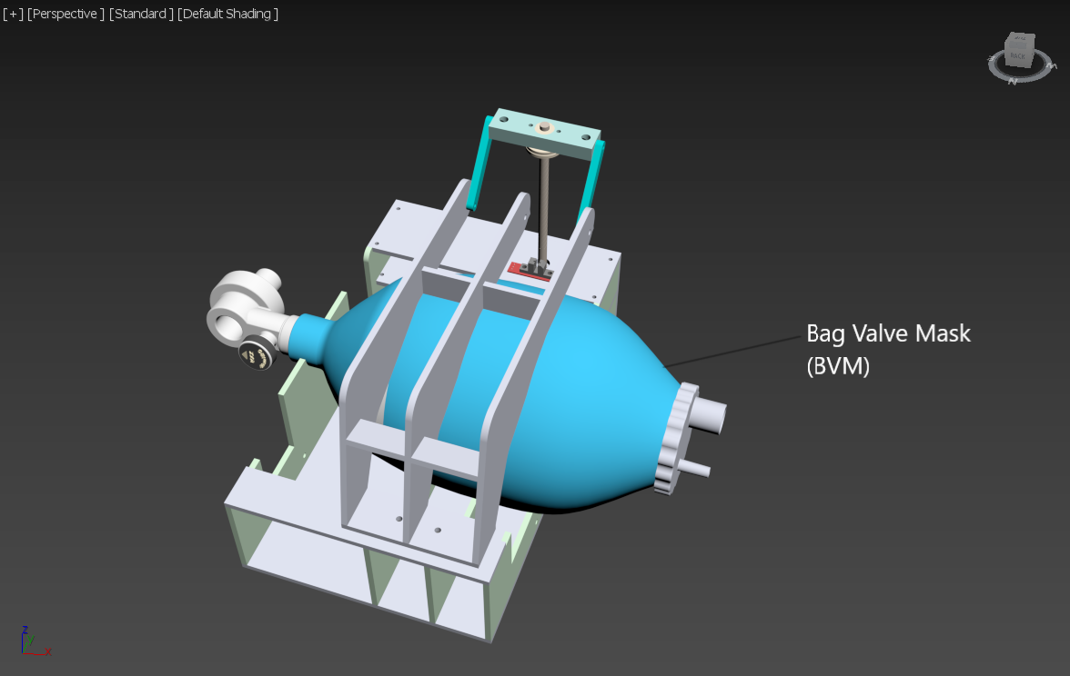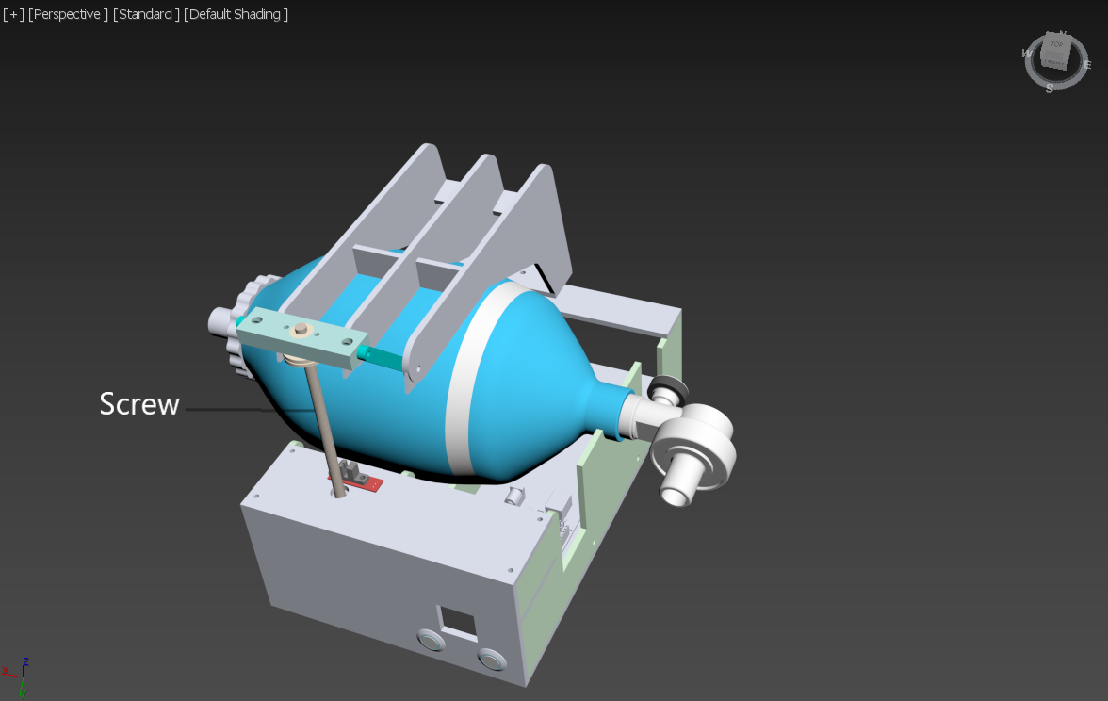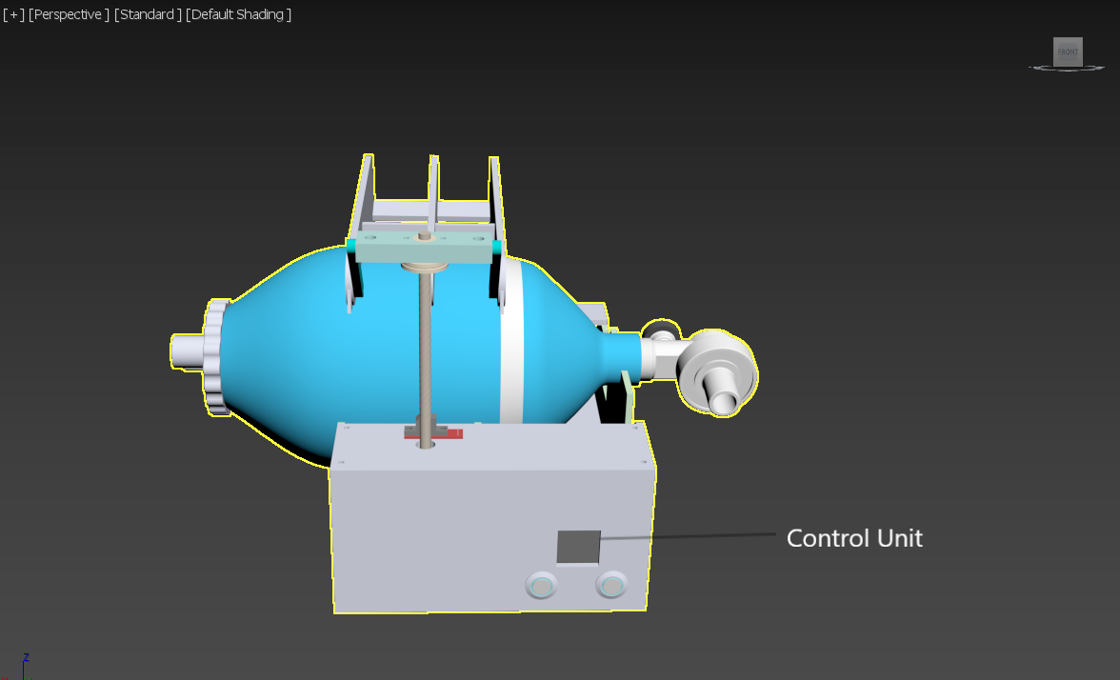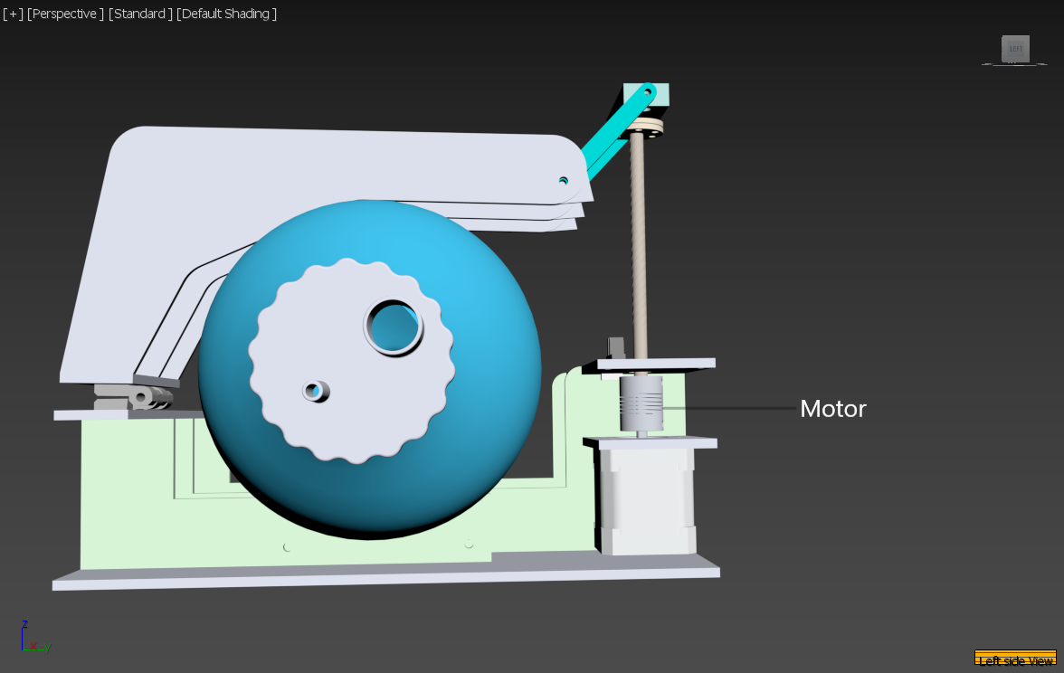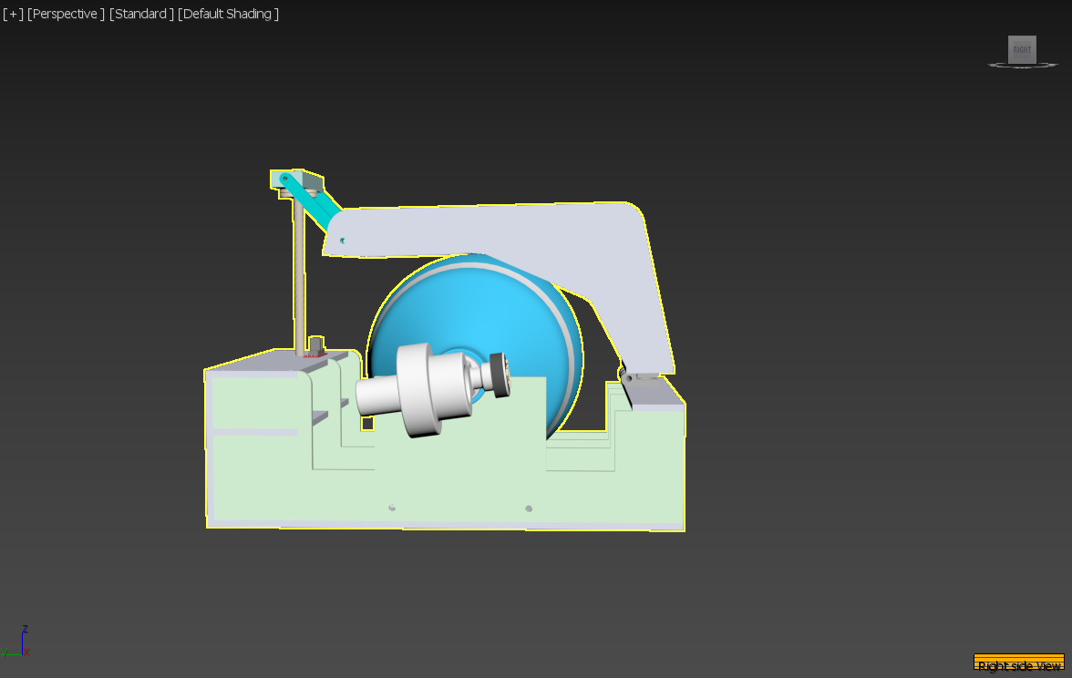

**Conclusion**

By this product we can give the patient a time frame which will allow the doctor to treat other patients. This is a complete package which consists of two two parts one with the patient and another with the operator. The product will send real time data to the server and the operator can monitor as well as control the motors and the servos. Operators can also monitor multiple patient’s data in realtime and the system is designed in such a way that any sudden change in data alerts the doctors and nurses realtime. Previous designs didn't have controllable switches and regulators but this product filled those gaps and enabled the doctors to control the air flow and the breathing pattern according to the patients' needs.

**Reference**

[1]COVID-19 Is India’s health infrastructure equipped to handle an epidemic, Brookings, 24 March 2020

[2]OpenLung BVM Ventilator by Cameryn Rhosyn, GitLab

[3]MIT E-Vent MIT Emergency Ventilator, 2020

[4] Augustine J. A., Seidel D. R., McCabe J. B. Ventilation performance using a self-inflating anesthesia bag: effect of operator characteristics. *The American Journal of Emergency Medicine*. 1987;5(4):267–270.

[5]0.55 Govt Beds Per 1,000 Population: Report Flags Low Govt Hospital Bed Availability In India MD Bureau By MD Bureau, *Medical Dialogues*, 25 March 2020.

[6] Emergency Care and Transportation of the Sick and Injured By *American Academy of Orthopaedic Surgeons.*

[7] Joshua T. Bucher, Jeffrey S. Cooper. Bag Mask Ventilation (Bag Valve Mask, BVM). *Proceedings of the 2010 Design of Medical Devices Conference DMD2010* April 13-15, 2010, Minneapolis, MN, USA.